Heaven’s Light is Our Guide
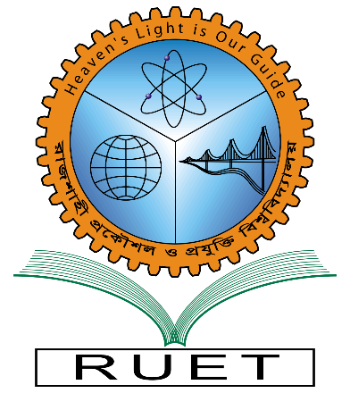
Rajshahi University of Engineering & Technology
Department of Electrical & Computer Engineering

Lab report

Course Code : CE 3100

Course Title : Civil Engineering Drawing

Date of experiment : 28- 01- 2026

Date of Submission : - 03- 2026

Submitted To: | Submitted By:
Dr. Md. Kamruzzaman  Professor,  Department of CE, RUET | Name : Md. Naimur Rahman Naim  Roll : 2210026  Registration : 1080  Session : 2022-2023  Department of ECE, RUET
- PENTAGON

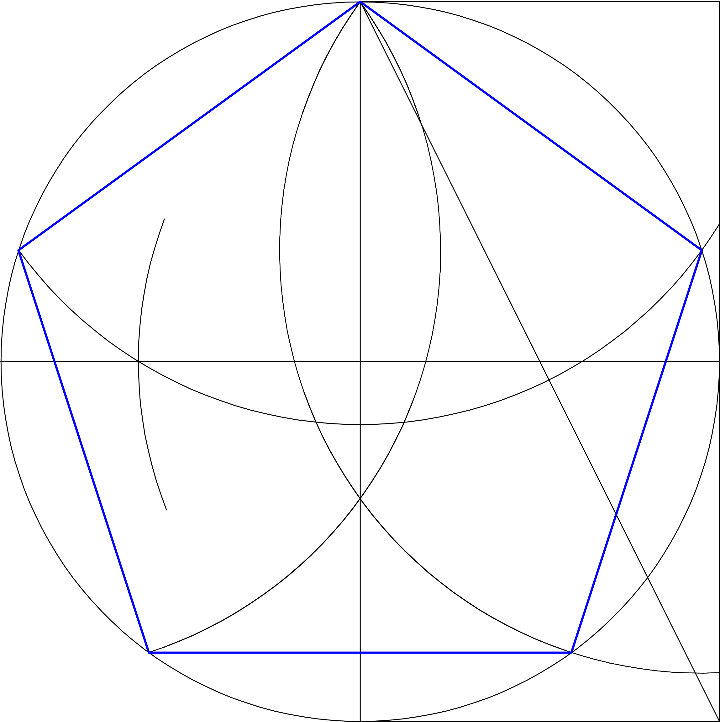

- HEXAGON

- OCTAGON

- ELLIPSE

- PARABOLA

- HYPERBOLA

